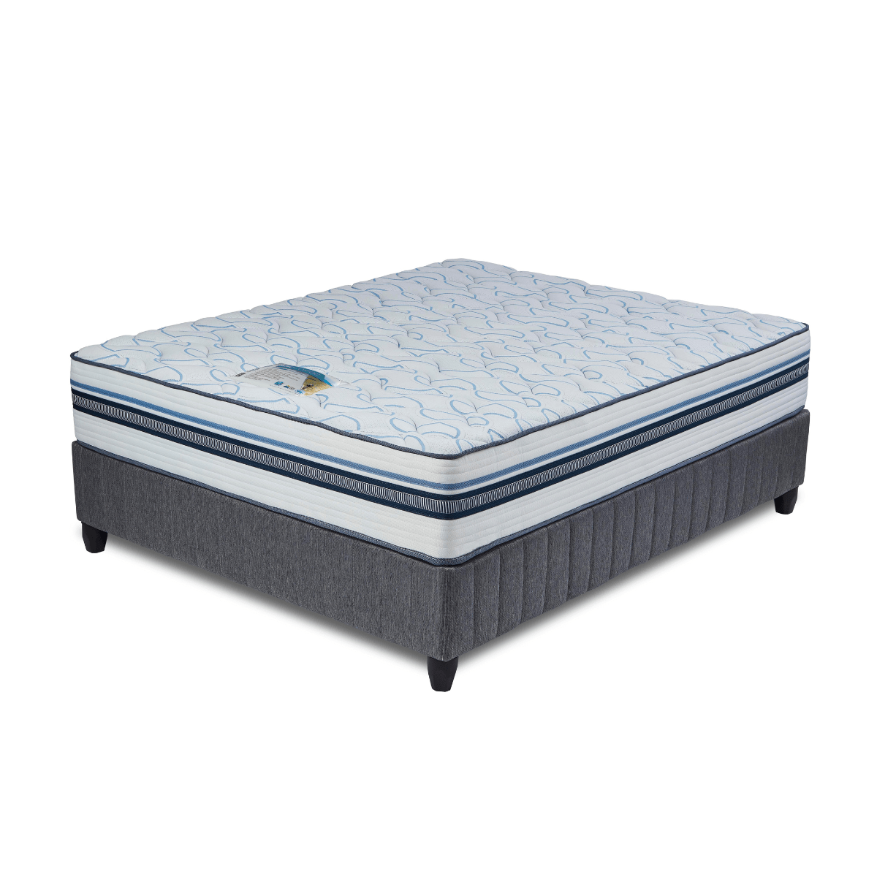


Model : Epic Comfort Bed Set
Supplier/Manufacturer : Cloud Nine
Range : Premium
Prices – Bed Set :
- Single Bed Set – R7819
- Three Quarter Bed Set – R8919
- Double Bed Set – R10909
- Queen Bed Set – R11839
- King Bed Set – R14919
Prices – Mattress Only :
- Single Mattress Only – R6159
- Three Quarter Mattress Only – R7089
- Double Mattress Only – R8879
- Queen Mattress Only – R9759
- King Mattress Only – R11609
Prices - Extra Length Bed Set :
- Single Extra Length Bed Set – R8449
- Three Quarter Extra Length Bed Set – R9639
- Double Extra Length Bed Set – R11779
- Queen Extra Length Bed Set – R12789
- King Extra Length Bed Set – R16119
Prices - Extra Length Mattress Only :
- Single Extra Length Mattress Only – R6649
- Three Quarter Extra Length Mattress Only – R7659
- Double Extra Length Mattress Only – R9589
- Queen Extra Length Mattress Only – R10539
- King Extra Length Mattress Only – R12539

*Please use this link for guideline for creating the page* - https://www.bedsonline.co.za/product/cloud-nine-epic-comfort-queen/
Cloud Nine Link - https://cloudnine.co.za/beds/premium/epic-comfort/

